DEDUCE Simulated Operating Characteristics of Phase 1 Dose Escalation Designs

*Report Date and Time: 2021-05-20 11:11:00*

*Software:* DEDUCE app version 1.0 available [here](https://bengarski.shinyapps.io/DEDUCE/)

# Objective:

To evaluate the operating characteristics of the following dose escalation design(s): **3+3, TARGET-CRM, CRM**

# Methods:

Trial operating characteristics are averaged over **100** simulated trials. Simulated trials have **4** dose levels labeled **-1,1,2,3**, starting on dose level **2**, and assume true toxicity probabilities of **0.05,0.12,0.2,0.3**. The target toxicity probability is **0.2**. One patient enrolls every **15** days on average. The DLT observation period is **28** days.

For the TARGET-CRM and/or CRM design, the prior toxicity probabilities per dose level are **0.05,0.12,0.2,0.3**. The cohort size is **3** and the maximum sample size is **18**. Patients belong to one of two cohorts: Cohort A or Cohort B. Patients with pre-specified characteristics (e.g. tumor type, tumor mutation) belong to Cohort B; all other patients belong to Cohort A. The TARGET-CRM design allows enrollment of Cohort B patients at one dose level below the current dose during the DLT observation period of the current cohort of patients. Cohort A patients enter a waitlist with a 50% chance to enroll when enrollment slots become available. The proportion of patients from Cohort B is **0.1**. Simulated trials using the TARGET-CRM and/or CRM designs are required to have a minimum enrollment of **0** Cohort B patients.

# Results:

**Accuracy:** Figure 1 presents the proportion of simulated trials that a given dose level was selected as the true MTD. The **TARGET-CRM** design has the greatest probability of selecting the true MTD (dose level 2).

**Safety:** Figure 2 presents the proportion of patients experiencing a DLT for each dose level.

**Patient Allocation:** Figure 3 presents the proportion of patients assigned to each dose level. The design has the greatest probability of assigning patients at the true MTD (dose level **2**).

**Study Duration:** Figure 4 presents the mean (+/- standard deviation) study duration in days for each design. The design has the shortest mean study duration.

Table 1 presents a summary of the operating characteristics for each design.

# Figures:

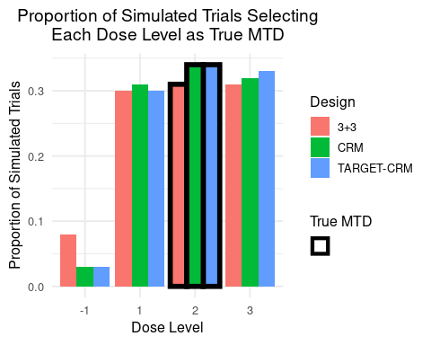

Figure 1: Proportion of simulated trials selecting each dose level as the true MTD.

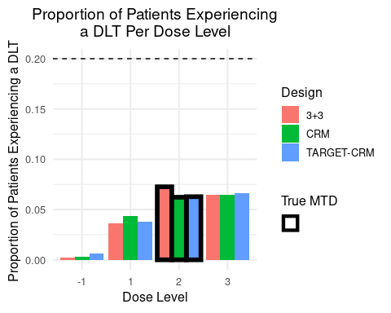

Figure 2: Proportion of patients experiencing a DLT per dose level. The target toxicity probability is denoted by the horizontal dashed line.

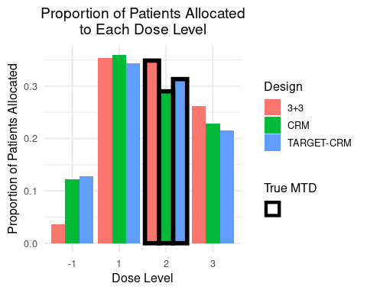

Figure 3: Proportion of simulated trials selecting each dose level as the true MTD.

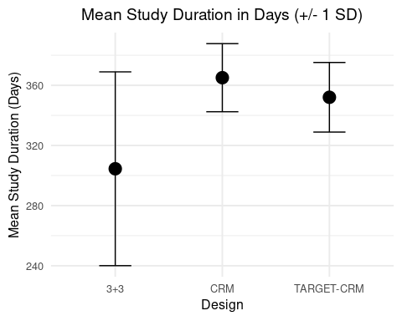

Figure 4: The mean (+/- 1 standard deviation) study duration in days.

Table 1: Summary of operating characteristics for the selected designs.

|  |  |  |  |
| --- | --- | --- | --- |
| Operating Characteristic | 3+3 | TARGET-CRM | CRM |
| Proportion of correct selection (PCS) | 0.310 | 0.340 | 0.340 |
| True MTD | 3.000 | 3.000 | 3.000 |
| Proportion of trials selecting dose -1 as true MTD | 0.080 | 0.030 | 0.030 |
| Proportion of trials selecting dose 1 as true MTD | 0.300 | 0.300 | 0.310 |
| Proportion of trials selecting dose 2 as true MTD | 0.310 | 0.340 | 0.340 |
| Proportion of trials selecting dose 3 as true MTD | 0.310 | 0.330 | 0.320 |
| Proportion of patients experiencing a DLT overall | 0.176 | 0.173 | 0.173 |
| Proportion of patients experiencing a DLT at dose -1 | 0.002 | 0.006 | 0.003 |
| Proportion of patients experiencing a DLT at dose 1 | 0.036 | 0.038 | 0.043 |
| Proportion of patients experiencing a DLT at dose 2 | 0.073 | 0.063 | 0.062 |
| Proportion of patients experiencing a DLT at dose 3 | 0.065 | 0.066 | 0.065 |
| Mean total sample size | 13.080 | 18.000 | 18.000 |
| Minimum total sample size | 9.000 | 18.000 | 18.000 |
| Maximum total sample size | 18.000 | 18.000 | 18.000 |
| Proportion of patients enrolled at dose -1 | 0.037 | 0.128 | 0.122 |
| Proportion of patients enrolled at dose 1 | 0.353 | 0.343 | 0.359 |
| Proportion of patients enrolled at dose 2 | 0.349 | 0.313 | 0.290 |
| Proportion of patients enrolled at dose 3 | 0.261 | 0.215 | 0.229 |
| Mean study duration in days | 304.500 | 352.048 | 365.077 |
| Standard deviation of study duration in days | 64.454 | 23.149 | 22.647 |
| Mean # of cohort B patients enrolled during DLT observation period (TARGET-CRM only) | NA | 0.530 | 0.000 |
| Standard deviation of # of cohort B patients enrolled during DLT observation period (TARGET-CRM only) | NA | 0.797 | 0.000 |